WEEK3 LAB

Q1 objective-.Take a random input of thousand number and perform the following algorithm
1.Time comparison of linear and binary search.
2.comparison of bubble sort,insertion sort,quick sort,merge sort.

-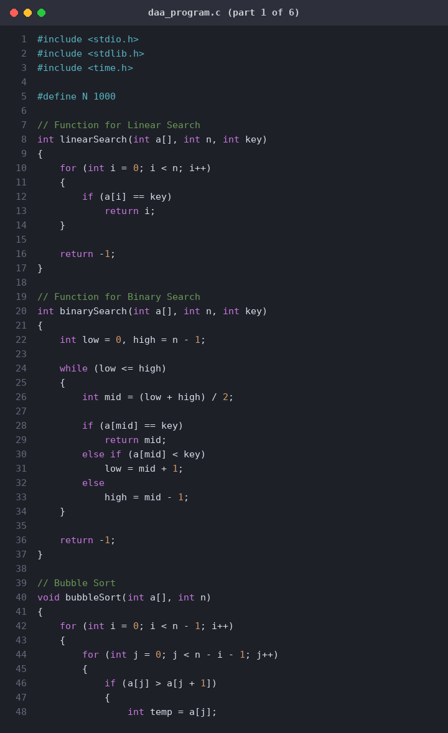

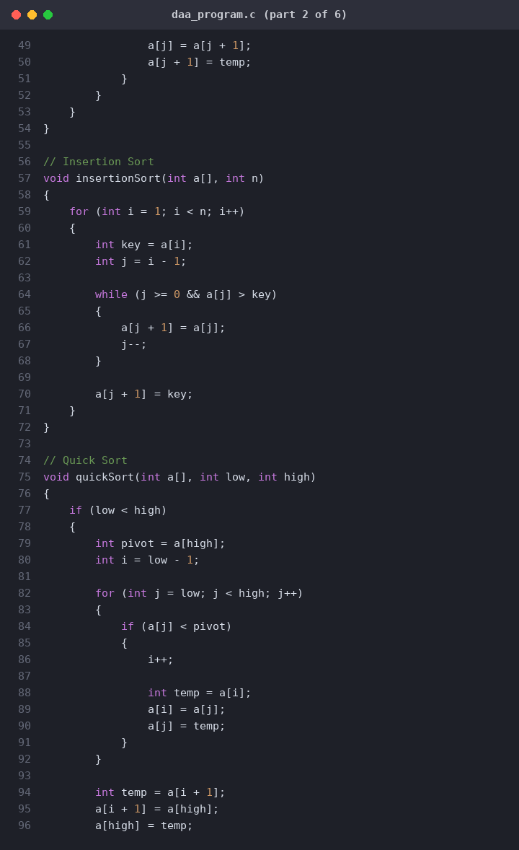
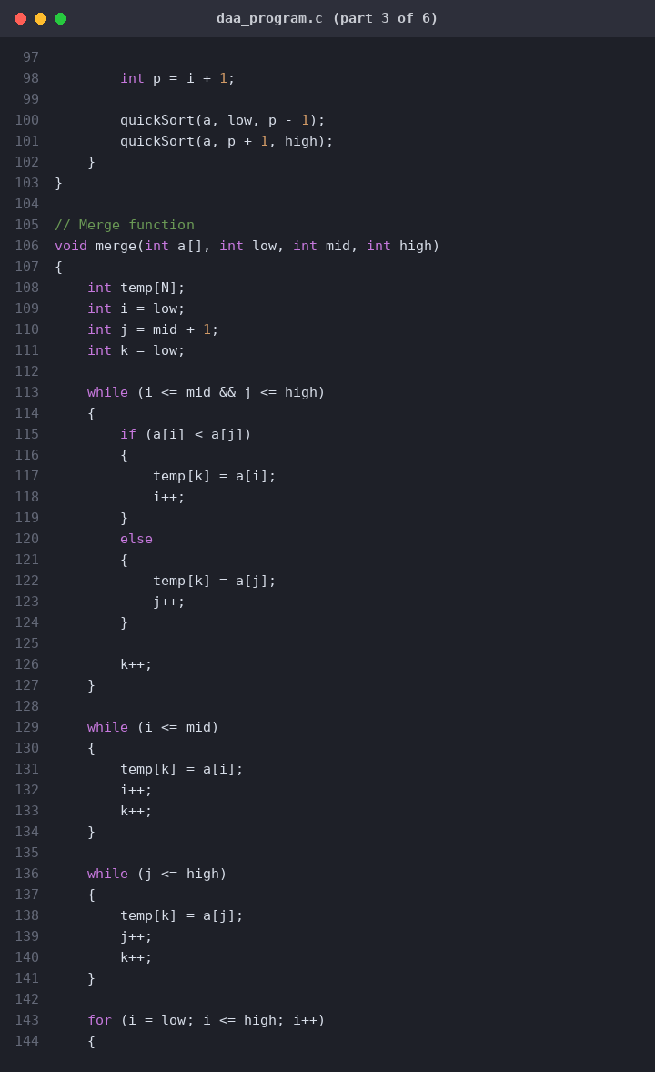
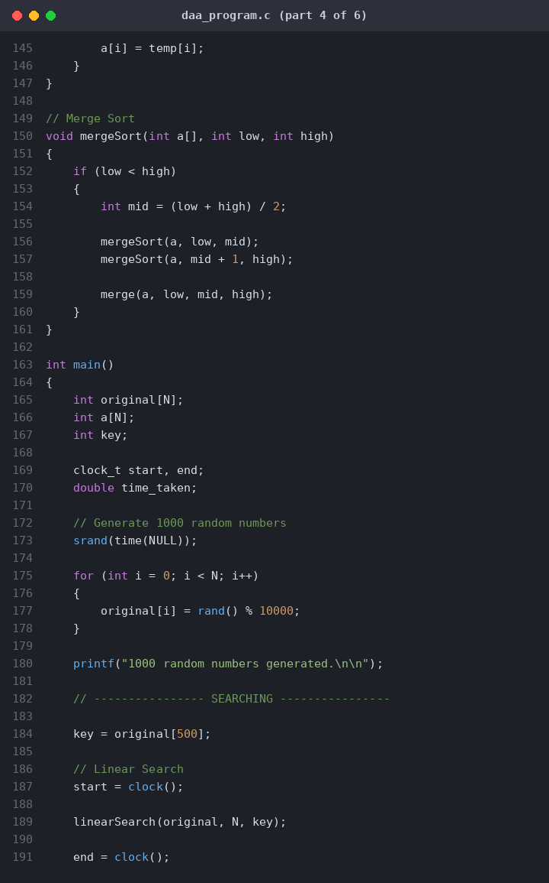
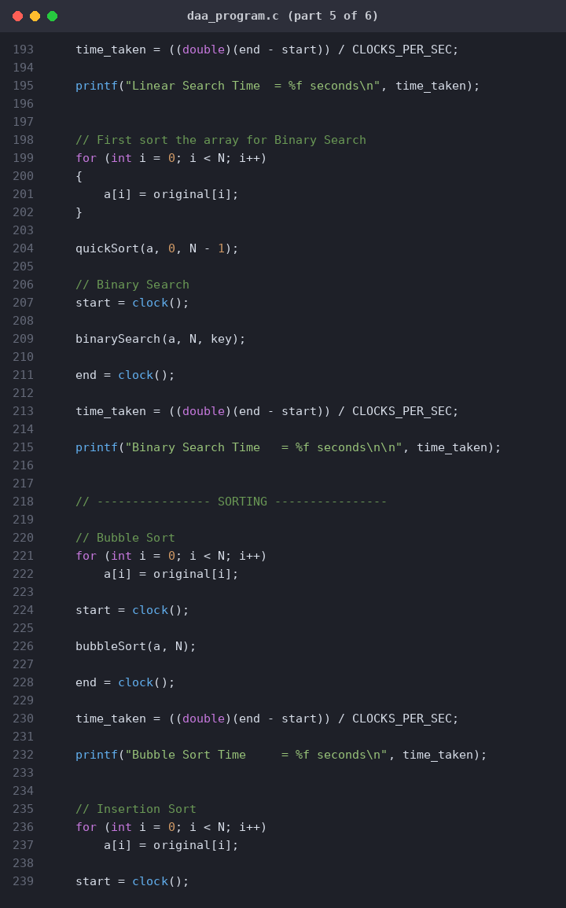
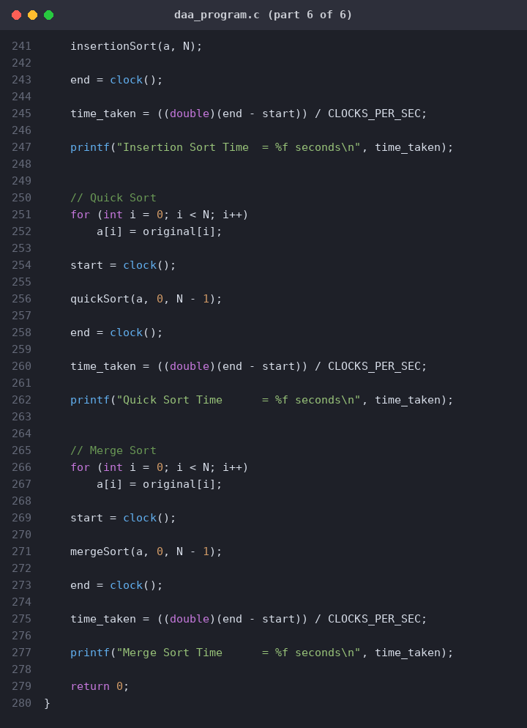
Code for graph:
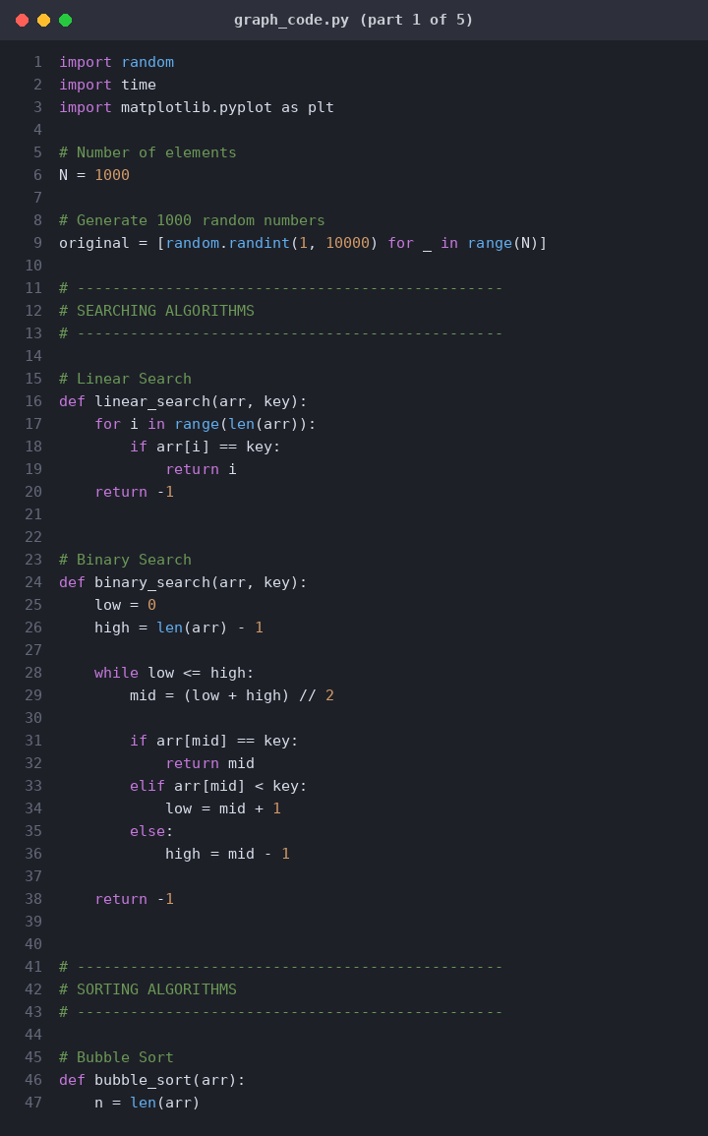
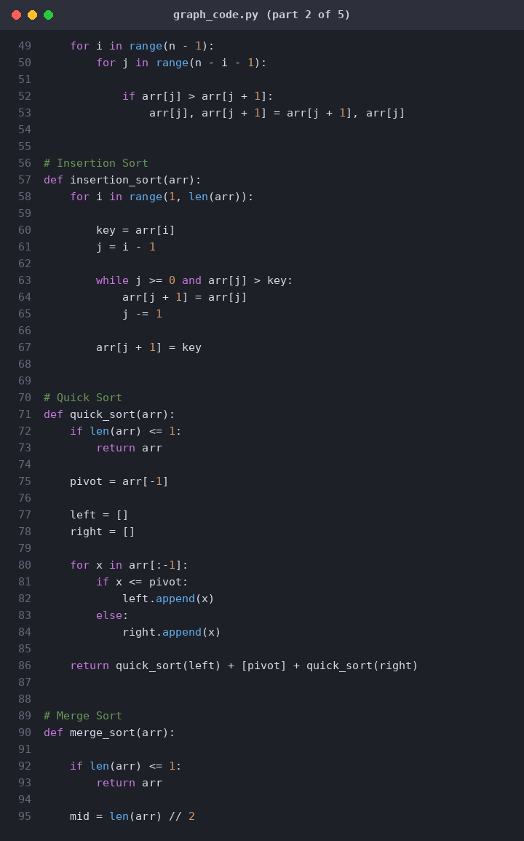
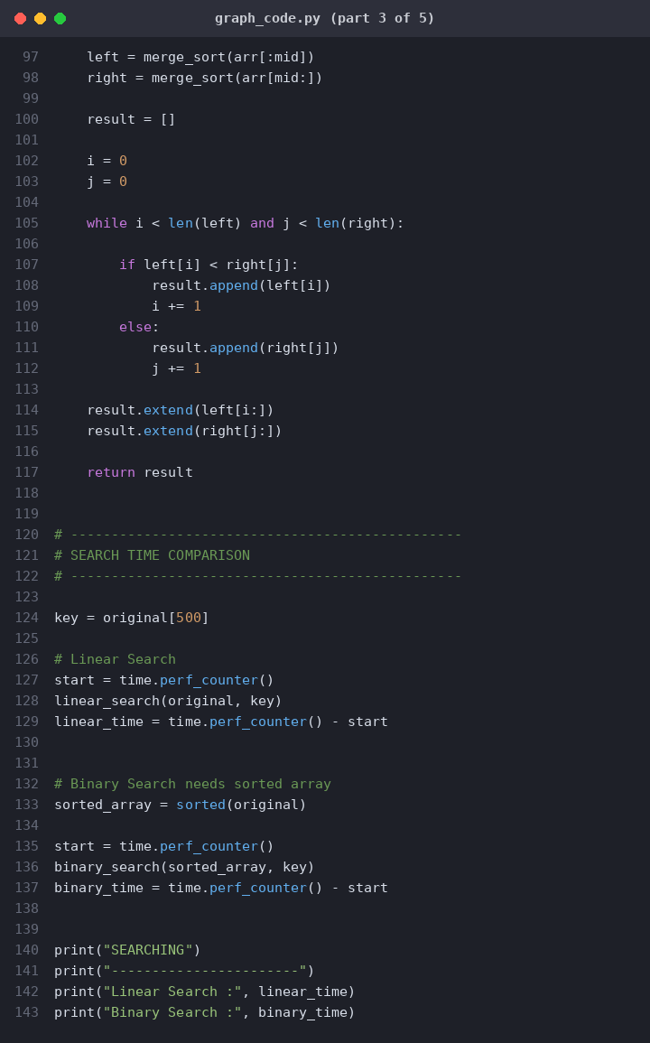
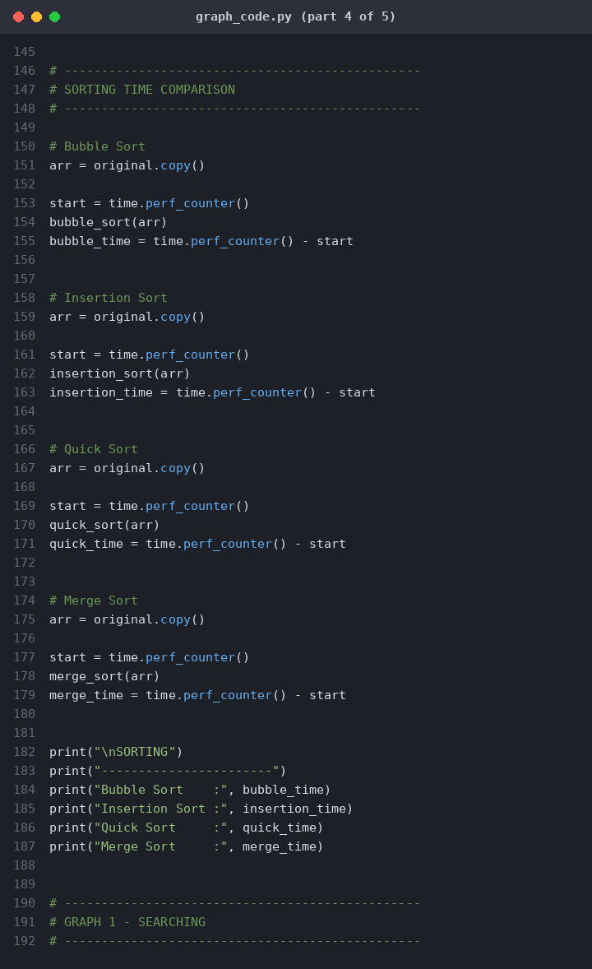
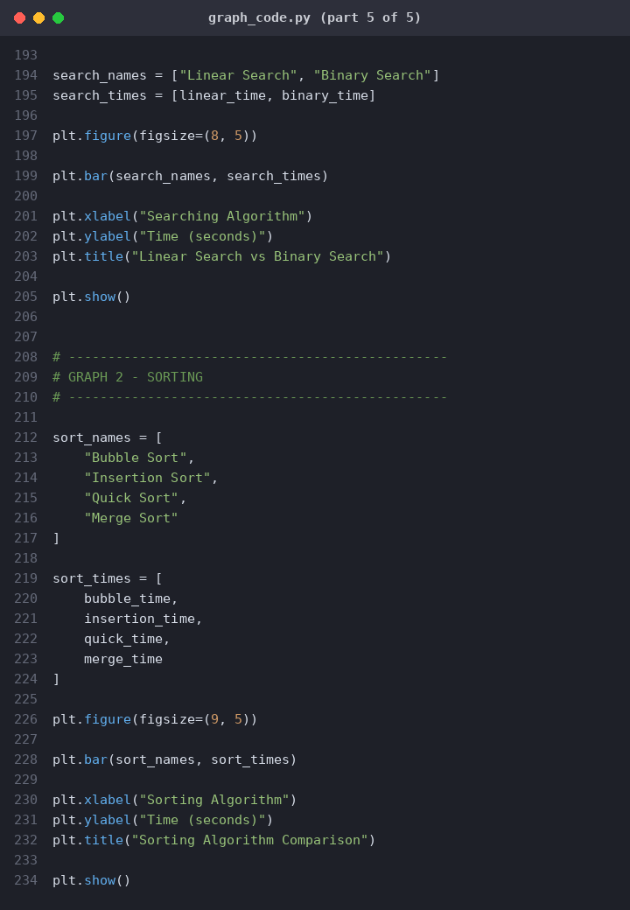

Output-
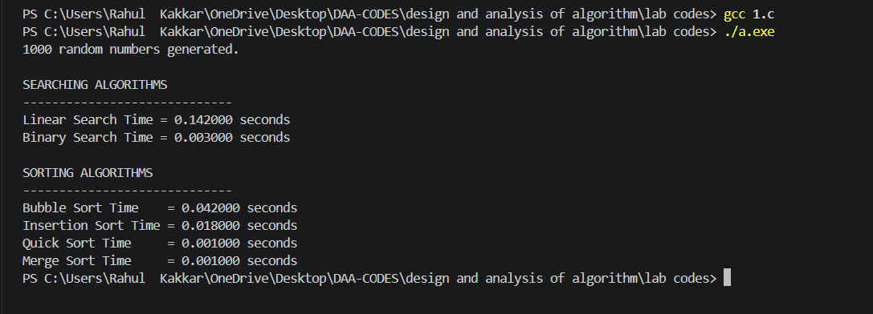
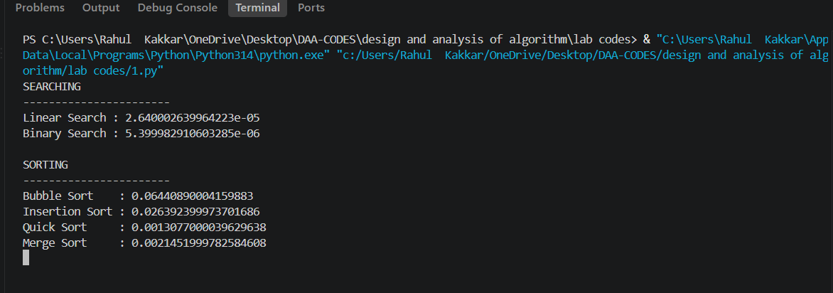

Graph of time comparison:
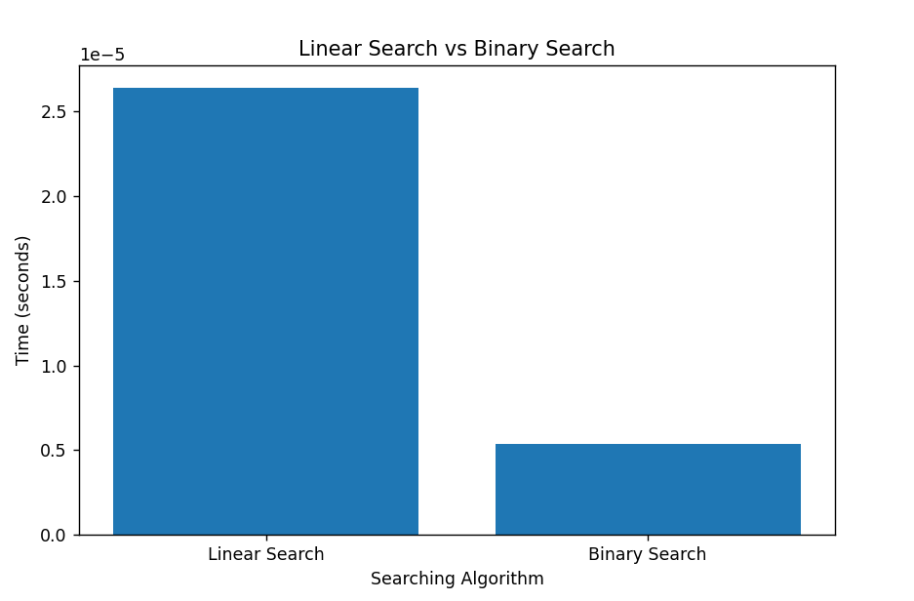
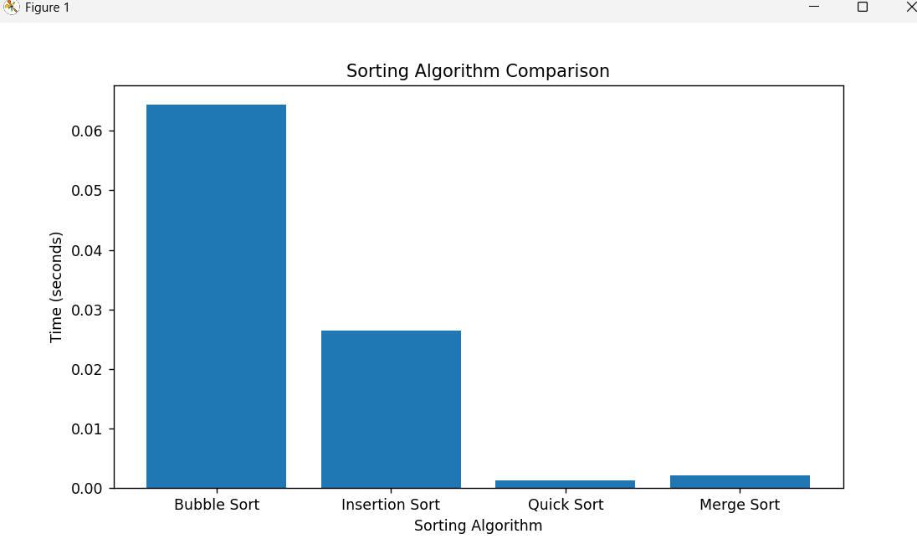

Understanding- This experiment helps us understand the difference in performance between various searching and sorting algorithms by measuring their execution time. For searching, Linear Search checks elements one by one, while Binary Search repeatedly divides a sorted array into two parts, making it much faster for large datasets. For sorting, Bubble Sort and Insertion Sort generally take more time as the number of elements increases, whereas Quick Sort and Merge Sort are usually faster for larger datasets. The Python program uses the time module to measure the execution time of each algorithm and matplotlib to represent the results graphically. The graphs make it easier to visualize how algorithm efficiency changes with the size of the input. Overall, this experiment shows why choosing an efficient algorithm is important when working with large amounts of data.

